**The Dance of Leadership:**

**(“Scent of a Woman”)**

**wayne.smith@csun.edu**

**[ updated: Thursday, June 30, 2022 ]**



**Course:** *MGT 360*

**Title:** *Management and Organizational Behavior* (3 units)

“Leaders must encourage their organizations to dance to music yet to be heard.”

“Leadership is the capacity to translate vision into reality.”

“People who cannot invent and reinvent themselves must be content with borrowed postures, secondhand ideas, [and] fitting in instead of standing out.”  
*---Warren Bennis (1925-2014)*

**Purpose**

The purpose of this document is to help structure the discussion for the critical management topic of *leadership*. In particular, we will use a clip from the popular movie “Scent of a Woman” (1992).

**Scene setup**

In this movie, Al Pacino plays a retired Lt. Colonel (“Frank”) who was accidentally blinded years ago in a military training exercise. He has a young assistant from a preparatory school who helps him played by Chris O’Donnell (“Charlie”). In this scene, Frank has traveled to New York over the Thanksgiving break with the help of Charlie, and the two have dinner reservations at a hotel’s elegant restaurant and ballroom. They sit down at a table and notice that at a nearby table a young woman (“Donna”, played by Gabrielle Anwar) is sitting by herself (she is waiting for her date, Michael, a male companion who arrives later on).

Frank, a curious individual, investigates the situation…

(roll clip)…

**Leadership Discussion Preface**

The instructor didn’t offer this clip because it’s cute; it is provided because many elements in the clip are working metaphors for one or more aspects of contemporary organizational leadership, often in very subtle ways. The hotel is the general workplace (context), the dance is a (technical) task, the music is the background work (environment) of the firm, and the characters are professionals, managers, and executives in a company. Frank and Charlie are supervisor and subordinate, respectively; Donna and Michael (not in the scene) are peers. Even the perfume, non-verbal communication, and personality interplay have corresponding roles in work life. Can you use leadership theory and practice to *explain* or *predict* what you observe?**Empowerment**

The following categories were taken from the five dimensions of the “Empowerment” Supplemental document. Identify an issue from the video clip for each cell below (not all cells may be relevant).

|  |  |
| --- | --- |
| **Personality Dimension (and Facets)** | **Issue(s)/Example(s) from the Movie** |
| *Self-efficacy*  (a sense of personal competence) |  |
| *Self-determination*  (a sense of personal choice) |  |
| *Personal Consequence*  (a sense of having impact) |  |
| *Meaning*  (a sense of value in activity) |  |
| *Trust*  (a sense of security) |  |

**Leadership Traits**

The following traits were taken (chiefly) from the textbook—Schermerhorn (Chapter 14) “Leading & Leadership Development”.

|  |
| --- |
| **Trait** |
| *Drive*  (successful leaders have high energy, display initiative, and are tenacious) |
| *Self-confidence*  (successful leaders trust themselves and confidence in their abilities) |
| *Creativity*  (Successful leaders are creative and original in their thinking) |
| *Cognitive Ability*  (successful leaders have the ability to integrate and interpret information) |
| *Job-relevant Knowledge*  (successful leaders know their industry and its technical foundations) |
| *Motivation*  (successful leaders enjoy influencing others to achieve shared goals) |
| *Flexibility*  (successful leaders adapt to fit the needs of followers and the demands of situations) |
| *Honesty and Integrity*  (successful leaders are trustworthy, honest, predictable, and dependable) |

***Personal* Practice-based Leadership Characteristics**

The following categories were taken from the Supplemental reading by *Warren Bennis*.

|  |
| --- |
| **Leadership Characteristics** |
| *Judgment*  (keen insight or foresight; persistent, tractable wisdom) |
| *Candor*  (openly and transparently challenges beliefs and assumptions; collaborative decisions) |
| *Crucible*  (transformative “rite of passage”; significant experience that causes permanent change) |
| *Compasses*  (clear and solid direction; assess results and alter course) |
| *Four Leadership Essentials*  (creates shared meaning; offers a distinctive voice; embodies integrity; has adaptive capacity) |

***Organizational* Practice-based Leadership Characteristics**

The following categories were taken from the Supplemental reading by *Kouzes/Posner*.

|  |
| --- |
| **Leadership Characteristics** |
| *Model the Way*  (establishes principles concerning the way people should be treated and the way goals should be pursued) |
| *Inspire a Shared Vision*  (envisions the future, creating an ideal/unique image of what the organization can become) |
| *Challenge the Process*  (searches for opportunities to change the status quo; looks for innovative ways to improve the organization) |
| *Enable Others to Act*  (fosters collaboration and builds spirited teams; actively involves others) |
| *Encourage the Heart*  (recognizes contributions that individuals make; shares in the rewards of their efforts; celebrates accomplishments) |

***Theory-based* Leadership Styles**

The following categories were taken (chiefly) from the textbook—Schermerhorn (Chapter 14) “Leading & Leadership Development”.

**“Classic” Leadership Styles**

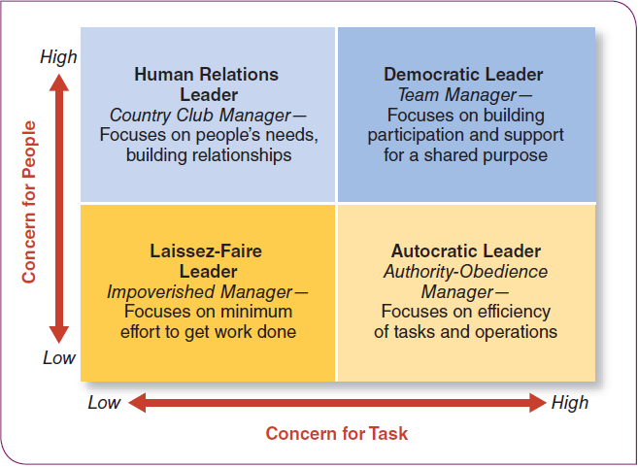

**“Situational” Leadership Styles**

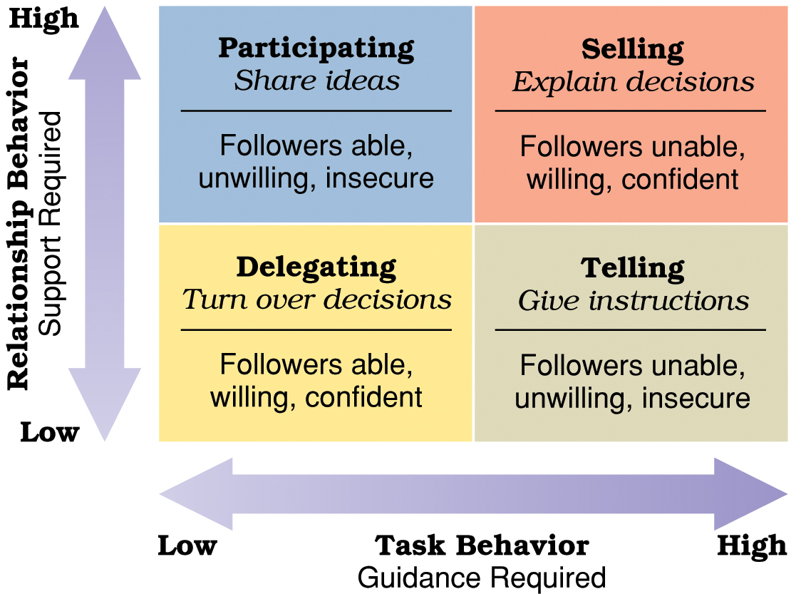

***Theory-based* Leadership Styles (continued)**

**“Path-Goal” Leadership Styles**

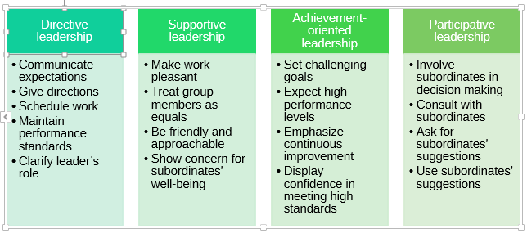

**Personal Leadership Foundations**

The following categories were taken from the textbook and other materials on leadership.

|  |
| --- |
| **Leadership Foundations** |
| *Charismatic Leadership*  (ability to inspire others in exceptional ways) |
| *Transformational Leadership*  (through personality, character, and insight, the leader aligns the employee’s goals with the leader’s goals) |
| *Interactive Leadership*  (inspires others through democratic, participative, connecting, and inclusive behaviors) |
| *Moral (“Servant”) Leadership*  (speaks and acts in ways that are consistent with the highest-level of integrity) |
| *Authentic Leadership*  (speaks and acts in ways that are consistent with a high-level of self-awareness and values) |
| *“Old-Fashioned”Leadership*  (defines and articulates a clear vision; accepts leadership as a responsibility; surrounds herself/himself with talented individuals; doesn’t blame others; maintains integrity; earns the trust of others; is regularly consistent not surprisingly clever) |